BARANI INSTITUTE OF INFORMATION TECHNOLOGY

PMAS AAUR

***N****AME :* ***M. K****HURRAM* ***S****HAHZAD*

*&* ***A****li* ***A****sghar*

*Arid No:18-ARID-1253 / 18-ARID-1159*

*DESCIPLINE: BS (IT) 7-A*

*SUBJECT: _VSS___*

*ASSIGNMENT NO: LAB Task 1 & 2__*

*SUBMITTED TO: Sir Abdullah___*

*DATE: 18/10/2021_*

**LAB 1 Task:**

Objective of Lab1 was to install CentOs.

1. Go to CentOs website, click on download, chose i386 OS, 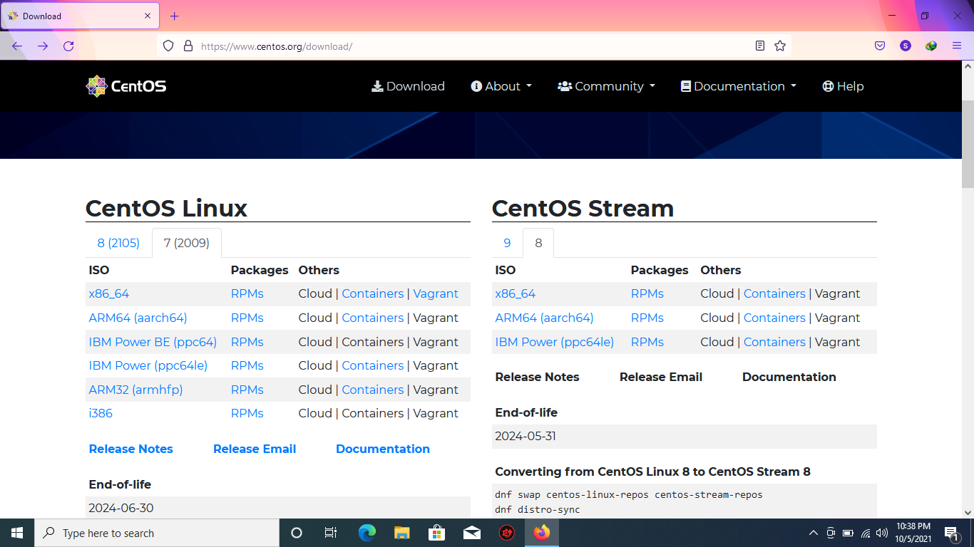
2. then click minimal version as shown in below picture to download iSO file.

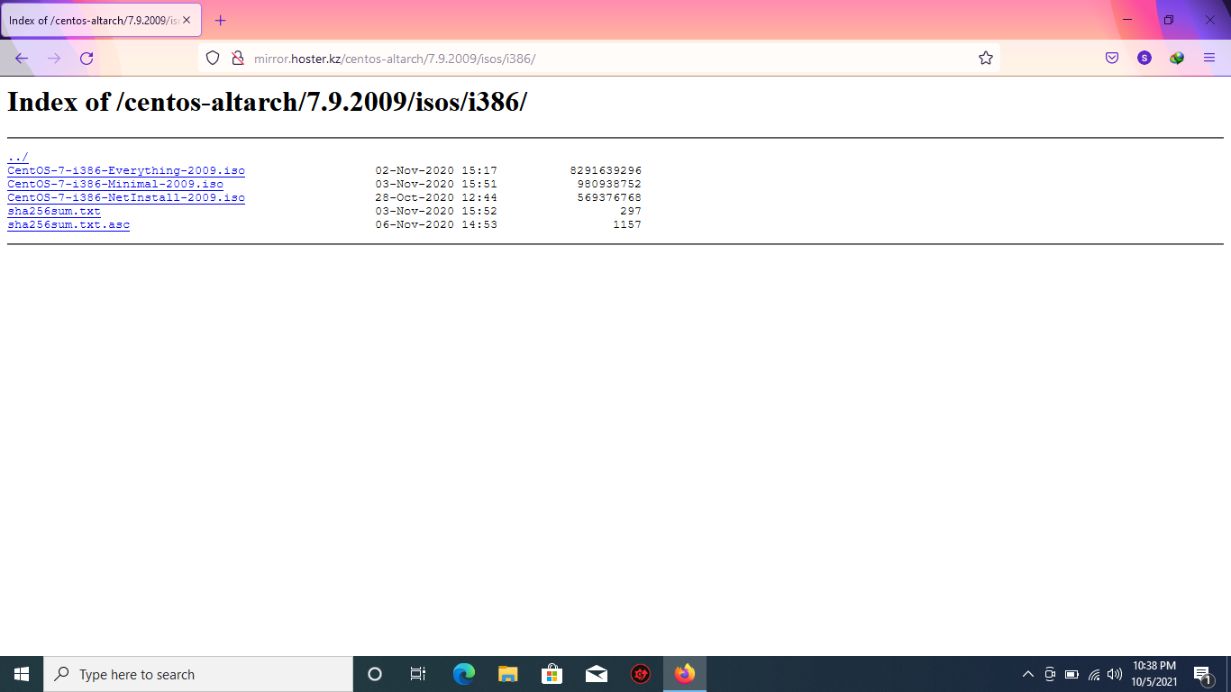

1. After successfully installing virtual box, create virtual machine by clicking ADD button.

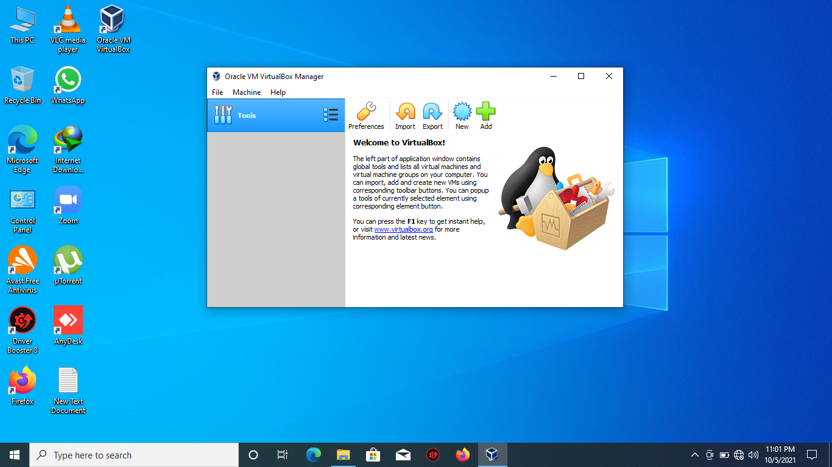

Write name of your choice, and chose iso file in machine folder.

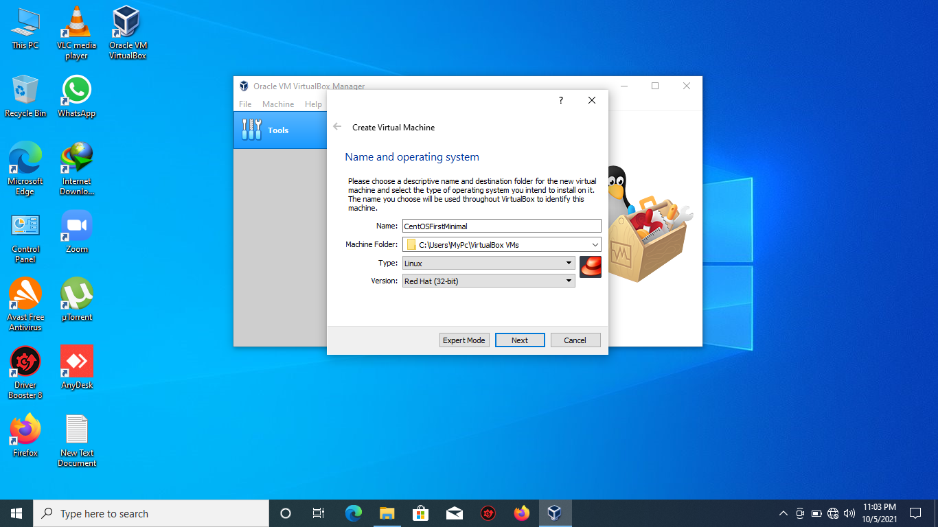

Chose RAM size.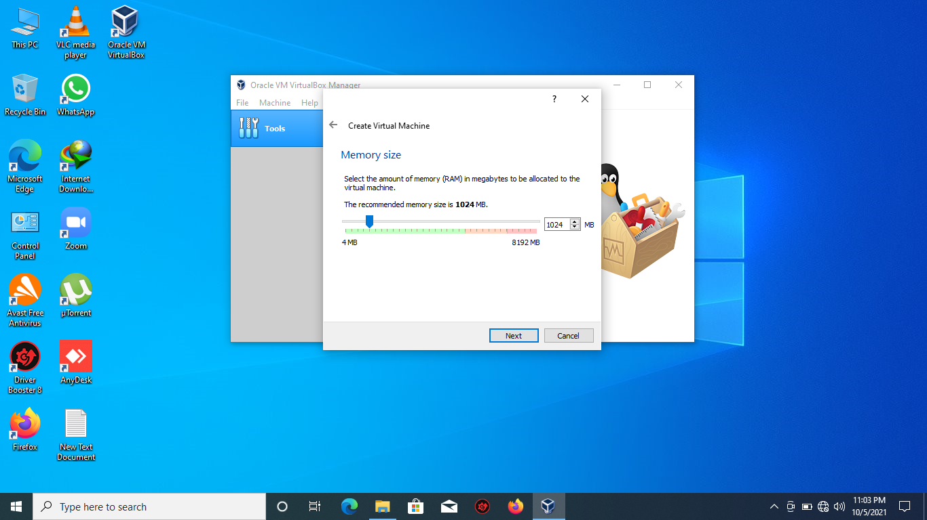

Chose create virtual hard disk.

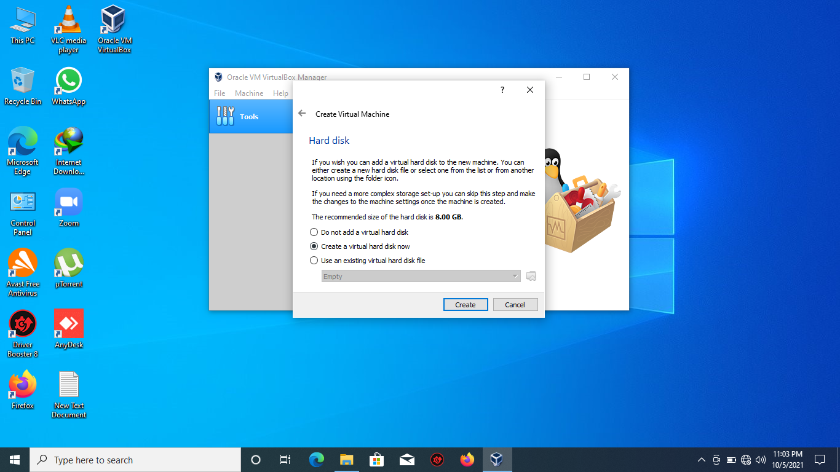

Clikc VDI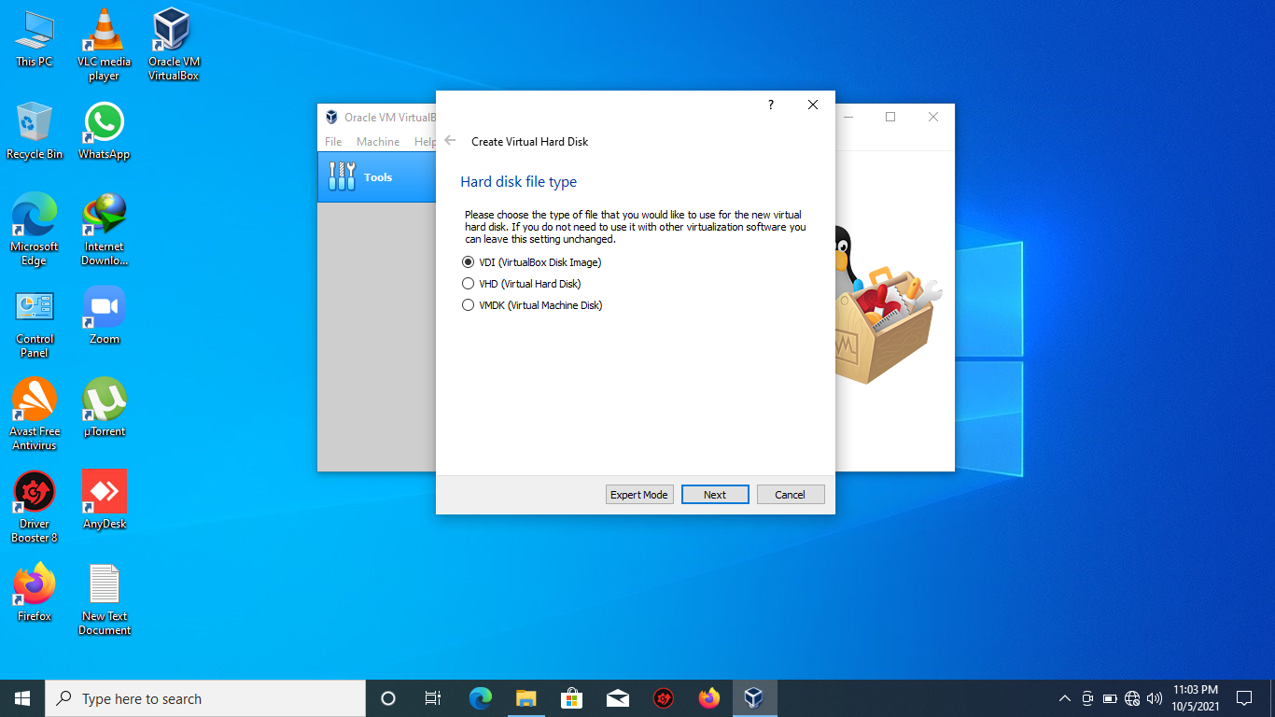

Chose dunamic

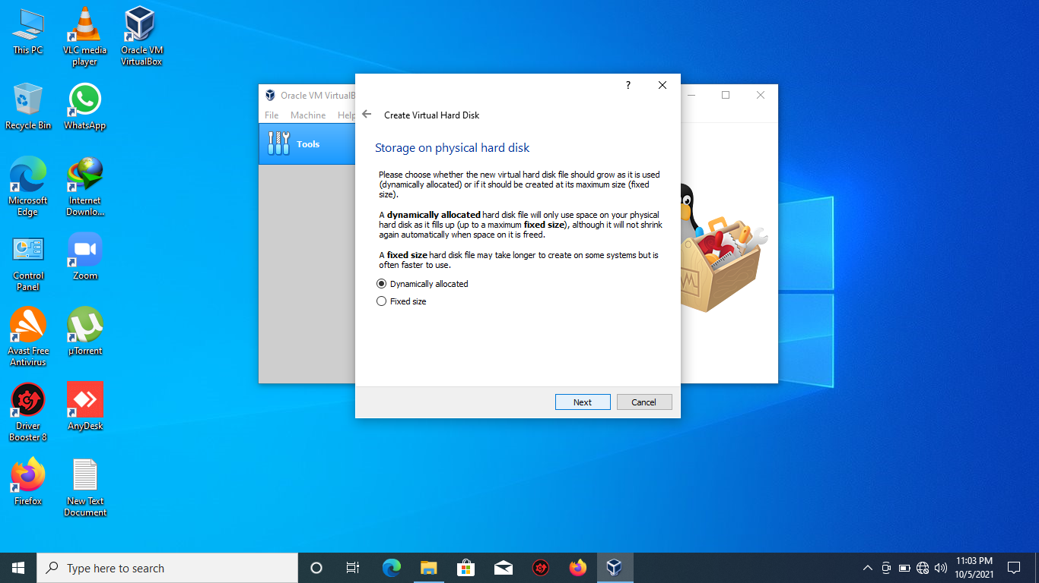

Now the Virtual file is created. Now press start for installaion of CentOS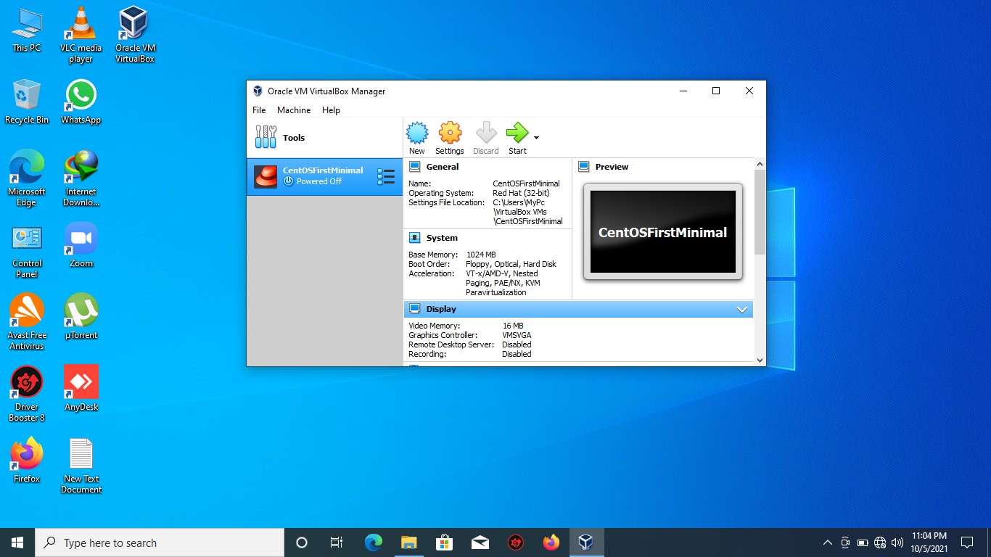

Chose the ISO file of CEntOS

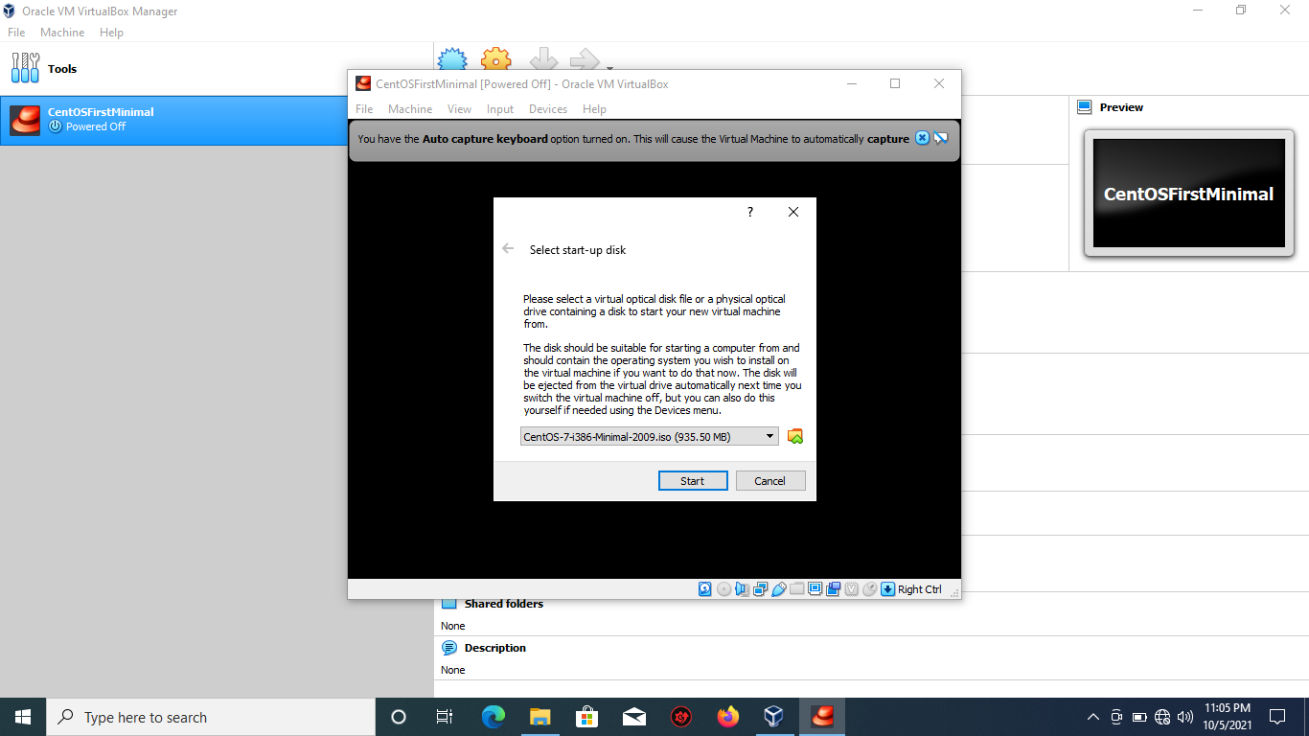

Create the default used if u want. Else no need.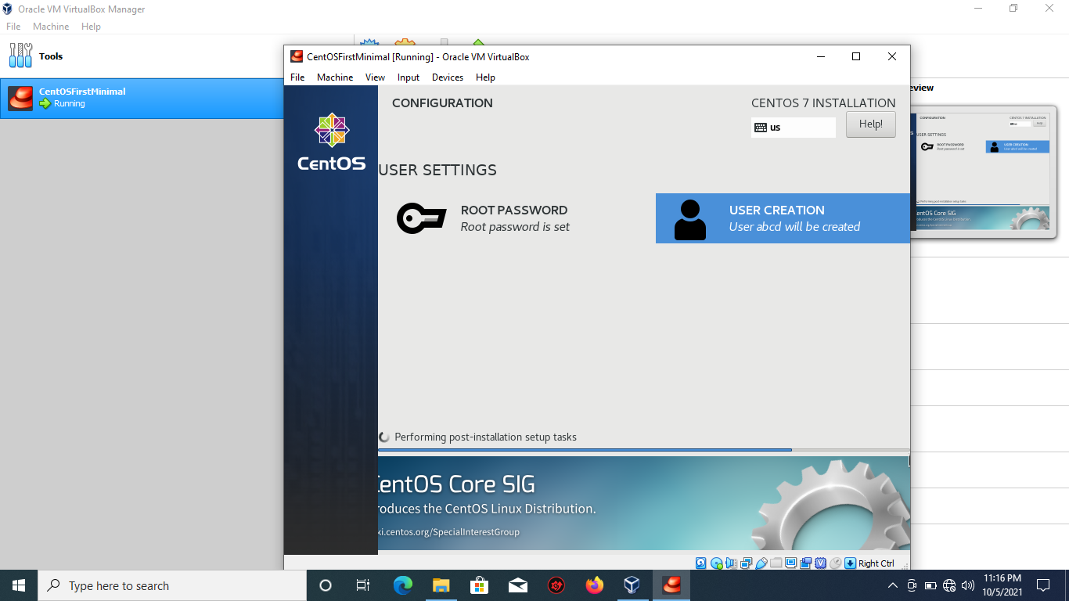

The CentOS is successfully installed. Congrats..

**LAB 2 Task:**

Objective of Lab2 was to practice basic Commands of Linux.

The screenshot of commands from lab-manual is attached with the picture.

I logged in as used abcd and type its password.

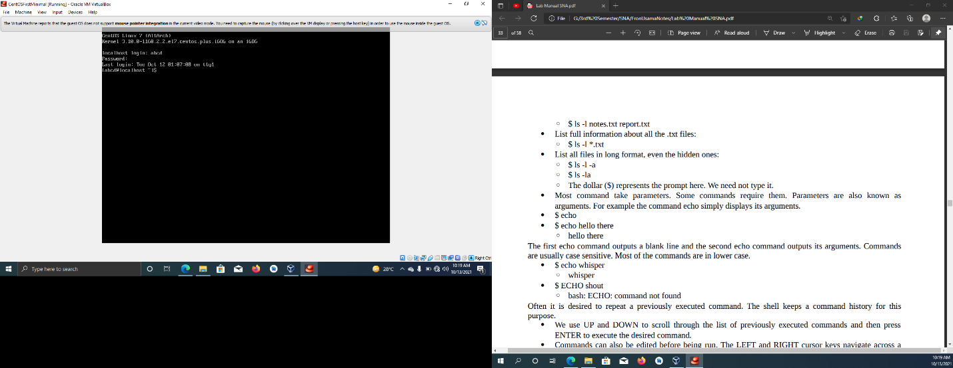

I run the basic ls command. And mkdir command to create the folder ‘khurram’

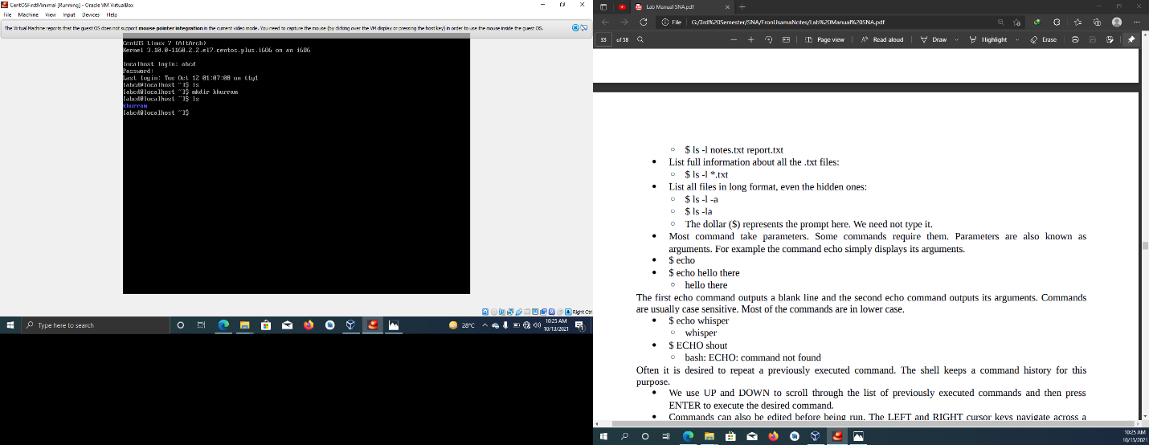

I run few commands. Touch to create a txt file. Pwd to check my present working directiry. The ls to to list down all files and folder, then cp command to copy the created text file to destination, then also cd command to change my directory.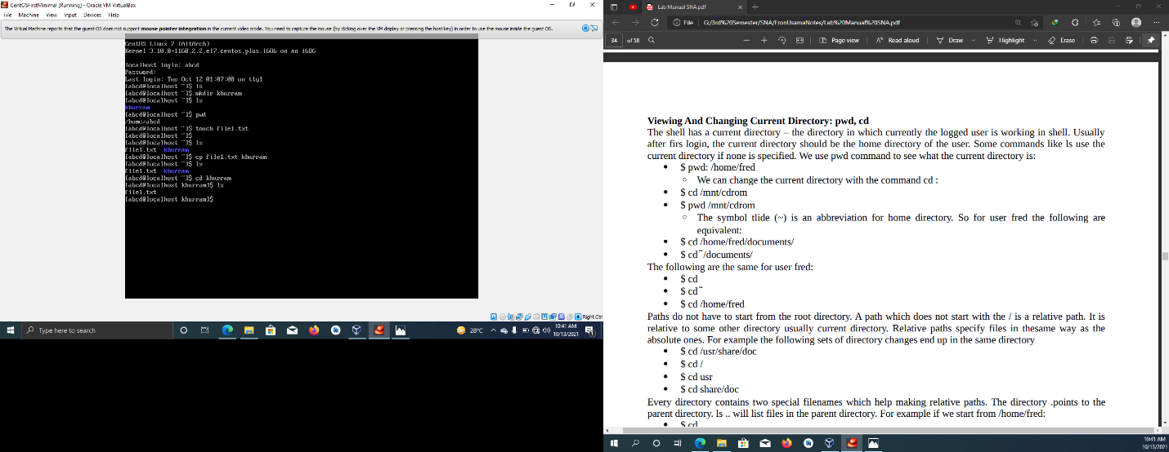

Here I use mv command to move the text file. Yhen cd and then ls to list down.

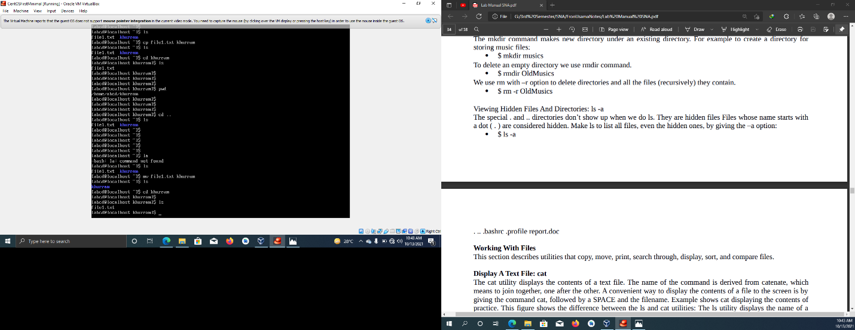

I use rmdir to remove the created folder ‘khurram’. Them re –r command to delete the text file I created.

